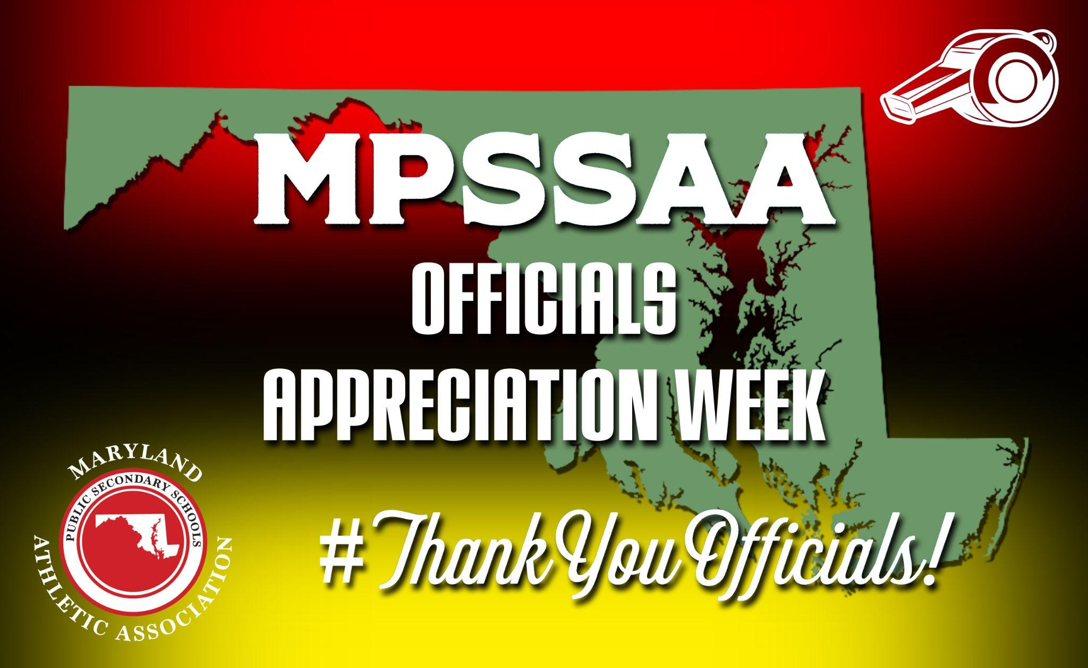

2023-2024 OFFICIALS APPRECIATION WEEKS

PUBLIC ADDRESS ANNOUNCEMENT
Fall: October 2-7
Winter: January 8-13
Spring: April 15-20

May we please have your attention for a special announcement. ___________ has been designated as “Officials Appreciation Week” by the Maryland Public Secondary Schools Athletic Association. Before we begin today’s athletic contest, NAME OF HIGH SCHOOL and NAME OF SCHOOL SYSTEM would like to recognize and thank the dedicated officials working today’s athletic contest.

During the last two years, we have been reminded just how important interscholastic athletics are to our member schools, students and communities. These opportunities and lifelong memories would not be possible without the hard work of today's officials who represent the nearly 5,500 MPSSAA registered officials, referees and umpires across the state of Maryland.

Please join us in thanking these officials by standing, if able, and applauding their dedication and service to our student-athletes, coaches, teams and sport.

Official’s Name: _______________________ Official’sName: _________________________

Official’s Name: _______________________ Official’sName: _________________________

Official’s Name: _______________________ Official’sName: _________________________

PAUSE FOR APPLAUSE

We also encourage everyone to participate in Officials Appreciation Week online by using the hashtag #ThankYouOfficials and tagging @MPSSAA_Org on X.

For more information on becoming an official, please visit the MPSSAA website at: Officials Association Central.

Again, thank you officials.

