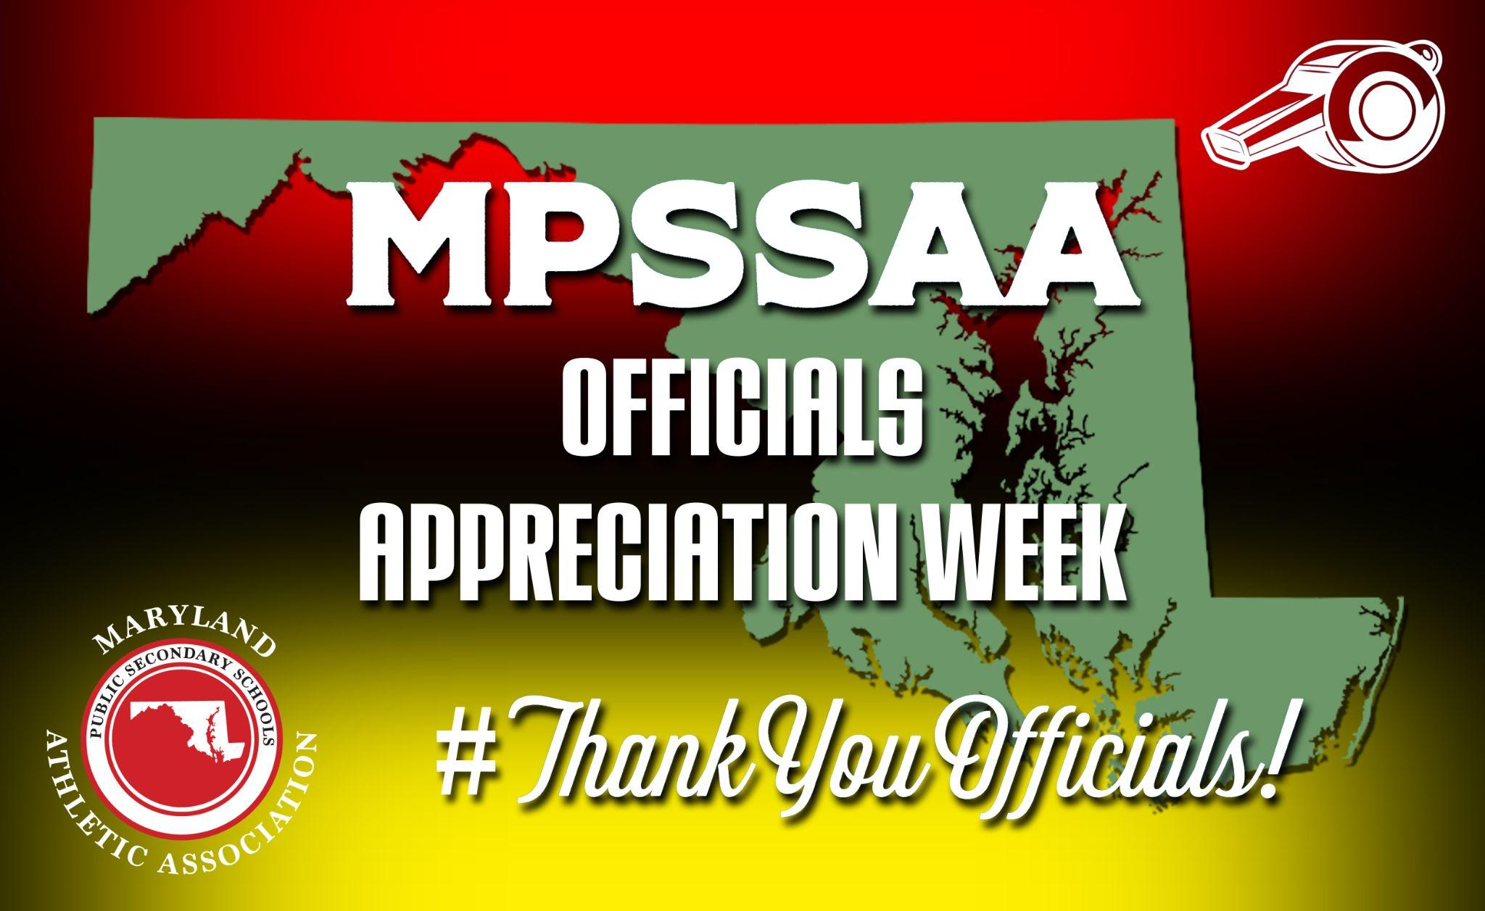

2023-2024 OFFICIALS APPRECIATION WEEKS
Fall: October 2-7
Winter: January 8-13
Spring: April 15-20

TEAM OR SCHOOL ACTIVITIES

- Read the Officials Appreciation Week Public Address Announcement
- Participate in Officials Appreciation Week online by using the hashtag #ThankYouOfficials and tagging @MPSSAA_Org on Twitter/X
________________________________________________________________
Additional Optional Activities
- Greet and escort officials on the day of the game.
- Meet and greet with officials after the game.
- Take a picture with both teams and the officials after the game.
- Thank you card signed by one or both of the teams.
- Provide water and/or snacks for the officials.
- Say thank you to an official you see before, during or after a game or contest.
- Post a message on the marquee of your school.
- Bring a sign to a game that says thank you to an official.
- Shake hands after a game or contest and thank an official for their service.
- Decorate facilities in officials’ colors - black and white.
- Team PSA.
- Individual school and county-wide advertisement and messaging.

